KANDAHAR UNIVERSITY

COMPUTER SCIENCE FACULTY

ATM Machin Requirements

As you know that we are in the (14) group of the projects. So the following members are performing the ATM machine project. the student of the project is the following.

* Khial Mohammad Mudasir

**GROUP 14**

* Rahmatullah Rahmati
* Dost Mohammad Qlamyar
* Jelalzai
* Hamid

Requirements and the implementation materials are the following which our ATM Machin will be performing inshallah:

ATM Machin has different functionalities which we will be describe as follow:

1. We can insert and withdraw the money from our system and we can save all these transactions.
2. We have five classes in our project.
3. Bank class:
4. This class have address, name and code variables.
5. This class have maintains function
6. ATM class:
7. This class have location, manage_by_bank variables.
8. This class has transection function.
9. Customer class:
10. This class have name, ID, Phone, Address variables.
11. This class don’t have any function.
12. Transection class:
13. This class have balance, Total_salary, card_number, Card_code.
14. This class have welcome and deposite functions.

The above are some requirements and implementation material to build an ATM machine. Maybe some requirements will be need but still they are not familiar for us. We hope that the above will be the proper and initial tips for the programs.

Our Future plane

In This project we have some porplem like this don’t have gui interface and it

Need to some more class.

in the future we will be add some more future to this project and we will br ,make a good interface for This insahallh .

**UML Diagram of project**

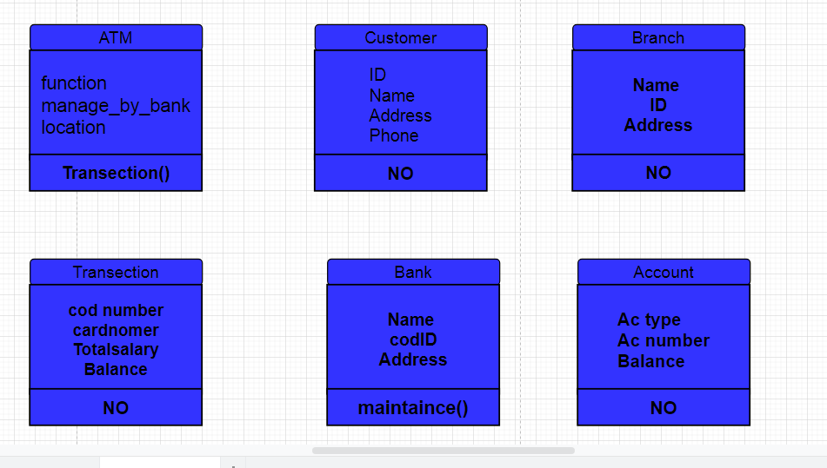

**Our Project Er_ Diagram**

